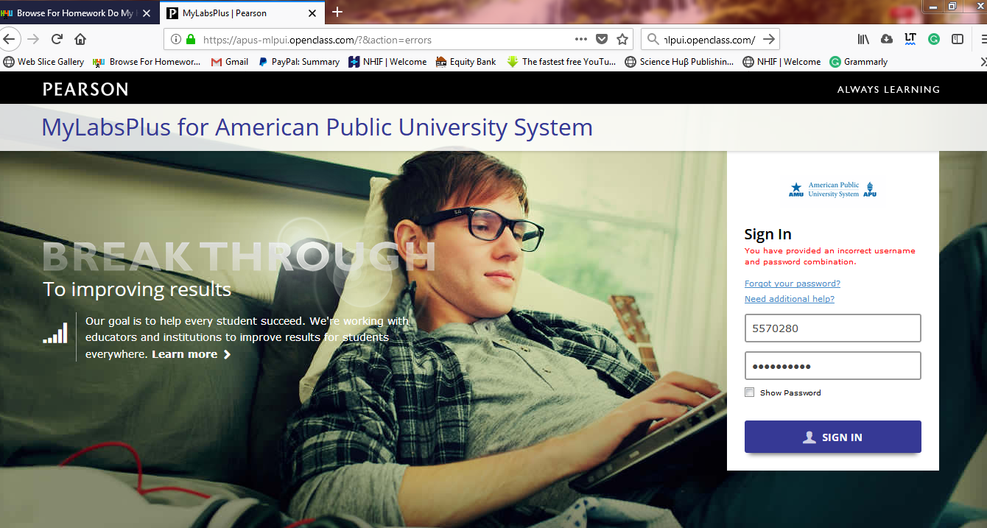

Kindly advice If this is the actual login site because the username and password detail you have given to me are inaccurate.
+254 728 430057 (WHATSAPP, if you have an account)
rkinyua09@gmail.com

